SSH Replace Password with Public Private Keys Authentication
Version 0.1
March 14, 2025

Authors:
Mohammed Khalil mk3441@att.com

Contents
Document Control 3
1 Introduction 4
1.1 Ubuntu Side 4
1.1.1 Azure Portal Approach 4
1.1.2 VM Approach 6
1.1.3 configuring the sshd_config 7
1.2 Window Side 7
1.3 Block All users password authentication 8
1.4 Issue with the Remediation Procedure by Security team 9
2 acronyms 9

Document Control
Below are the publication date, author’s initials, and reason for publication for the current and any previous versions of this document.
Version | Publication Date | Author | Reason for Publication
0.1 | 04/14/2025 | MK | Issue Remediation

Introduction

Public/private key will be replace the password authentication. The procedure will be executed in 3 steps:
- Generate the ssh private/public keys. Initially, allow both authentications, password and ssh private/public keys authentication (section 2.1).
- Install the private key in window client and make sure that you can authenticate using the private/public keys mechanism (section 2.2).
- Once step 2 is successful, disable password in all users and switch over to public/private key authentication. (section 2.3).
Below is the description of the security issue:
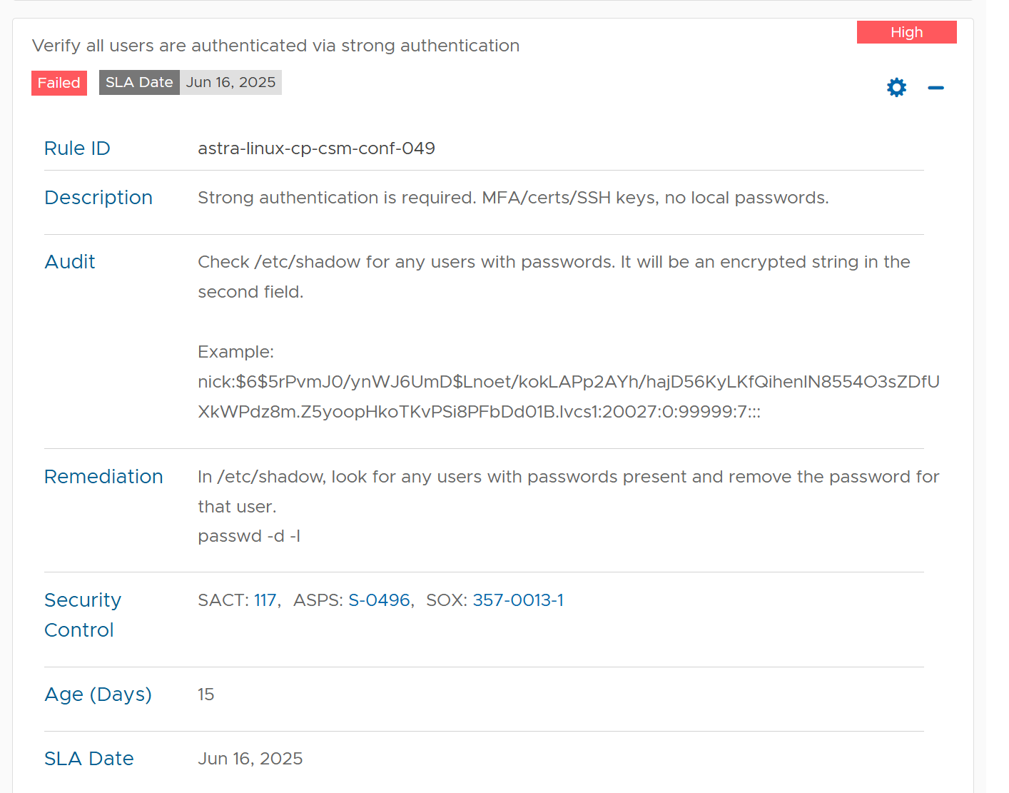

Ubuntu Side

Azure Portal Approach

- Search for SSK Keys
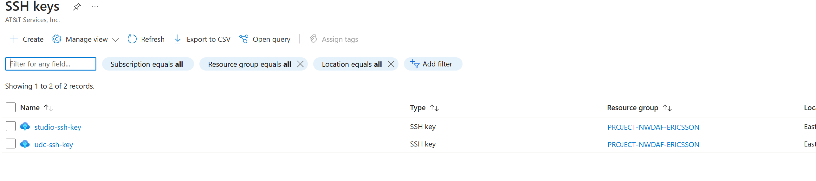
- Click in create. Fill up the following information:

  - Subscription
  - Resource group
  - Name for your key
  - Click review and create
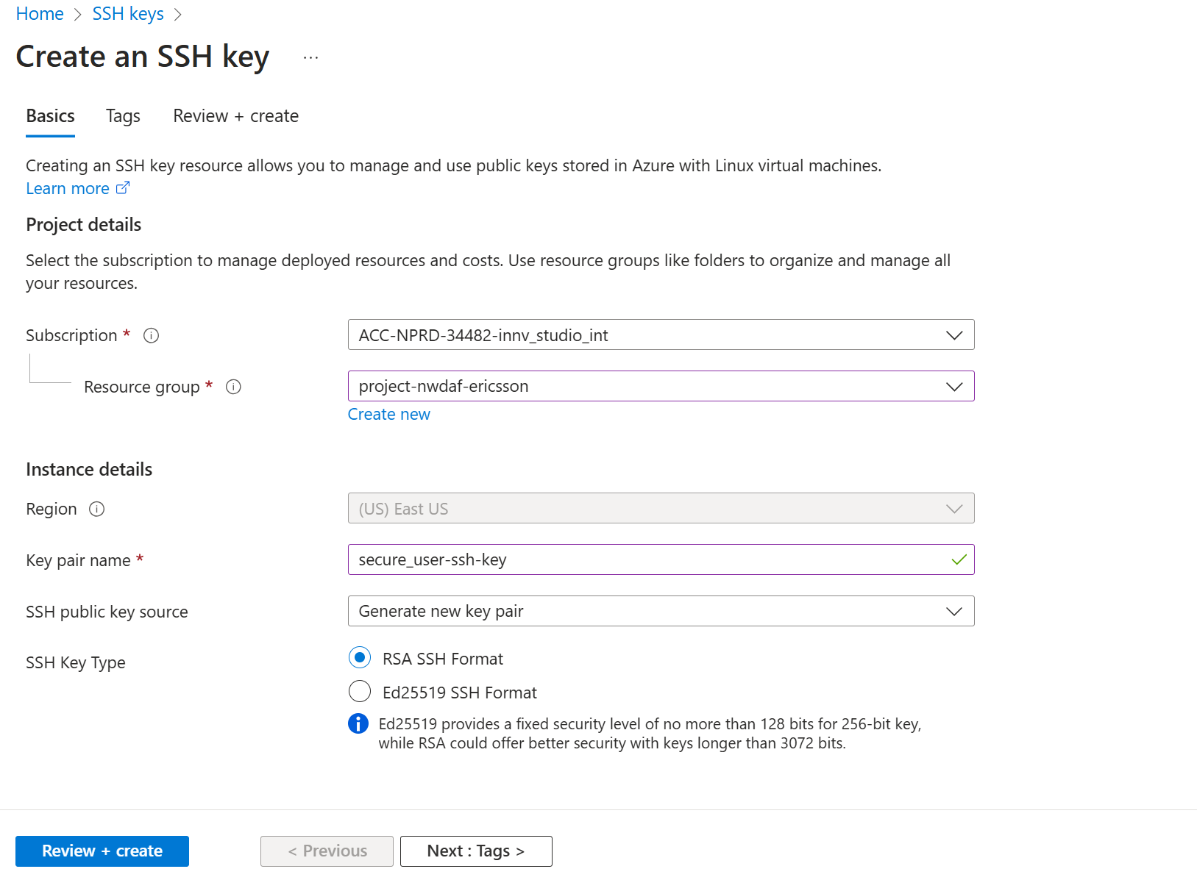
- When you click create, you will be prompted by. Select down load private key
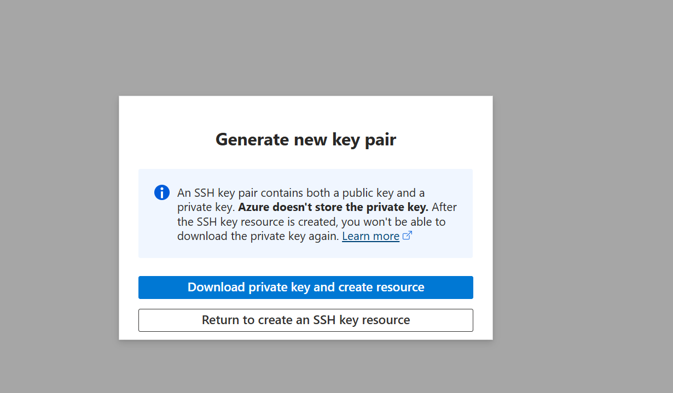
- Make sure that the public key is generated:

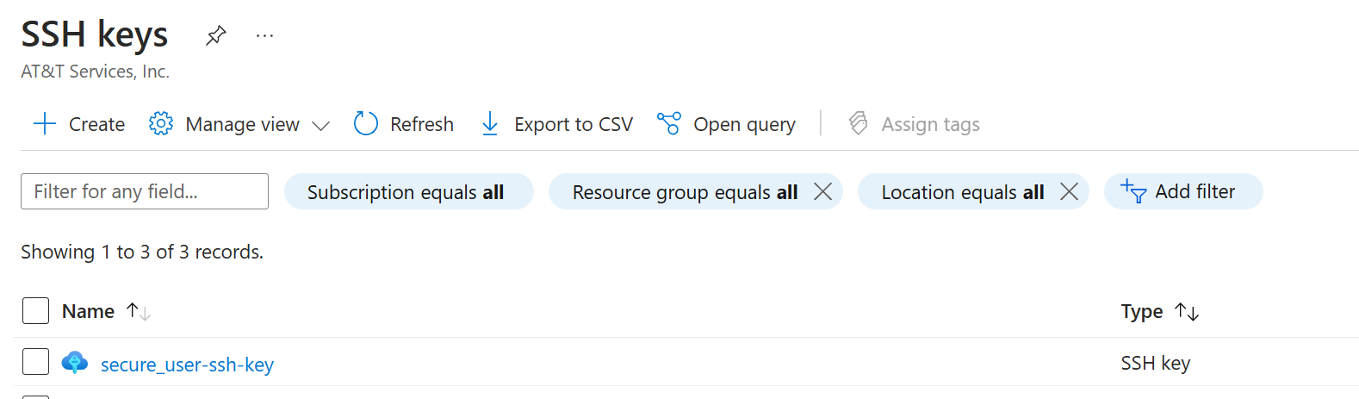

- Click on the generated public key and copy the public key
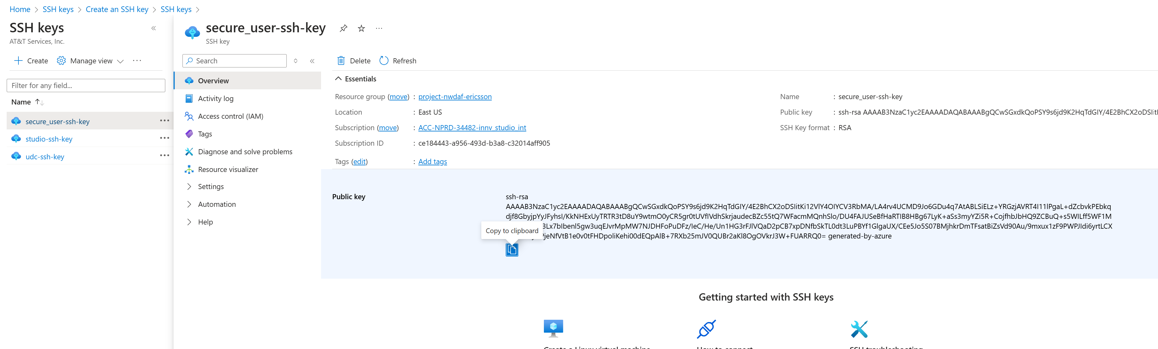
- Paste the key in the VM in the file <your home>/.ssh/ ssh_authorized_keys

VM Approach

A new directory .ssh will be created and public key and private key will be generated in this directory with the execution of the following commands:
- mkdir -p /home/user1/.ssh
- cd /home/user1/.ssh
- run command
  - ssh-keygen -t rsa -b 4096
  - 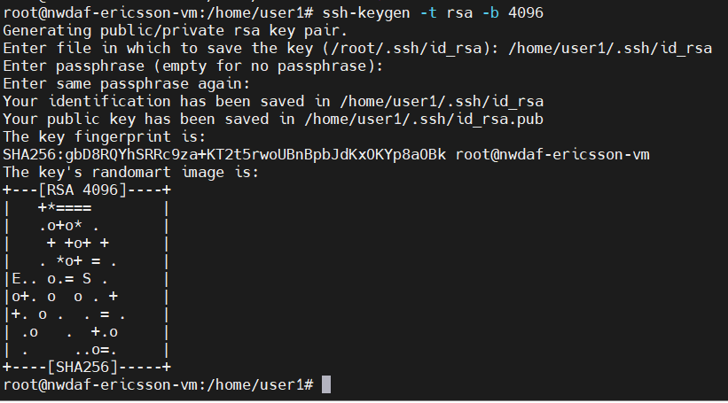
- cp id_rsa.pub ssh_authorized_keys
- chmod 600 /home/user1/.ssh/ssh_authorized_keys
- chown user1:user1 /home/user1/.ssh/ssh_authorized_keys

configuring the sshd_config

in the VM machine:
- sudo vi /etc/ssh/sshd_config, add the following lines
- AuthorizedKeysFile %h/.ssh/ssh_authorized_keys
- PasswordAuthentication yes , initially allow password authentication
- PubkeyAuthentication yes
- PermitRootLogin prohibit-password
- SAVE and EXIT
- sudo systemctl restart ssh

Window Side

We will use MobaXterm for remote VM access. Configuring MobaXterm to use SSH public/private keys authentication as follows:
- store the private key id_rsa ,generated in VM machine or portal in .ssh window local directory.
- Open MobaXterm.
- Click on Session → SSH.
- In the Remote host field, enter your VM IP address.
- Under Specify Username, enter your Ubuntu username (e.g. user1).
- Click on the Advanced SSH Settings tab.
- Enable Use private key and browse to select your private key file (id_rsa.ppk or id_rsa).
- Click OK and Save the session.

Block All users password authentication

- To disable password login for secure_user, run:
  - sudo passwd -d -l secure_user
  - This removes the password hash, making it empty.
- repeat step 1 for all users .You can do that from secure_user account.
- go to /etc/shadow you should find all users as:
- PasswordAuthentication no
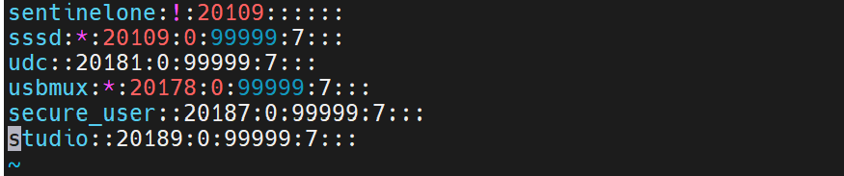
- repeat step 1,2 for all users
- sudo vi /etc/ssh/sshd_config,
- AuthorizedKeysFile %h/.ssh/ssh_authorized_keys
- PasswordAuthentication no , disable password authentication for all users
- PubkeyAuthentication yes, allow private/public key authentication
- PermitRootLogin prohibit-password, disallow root from using password with ssh.
- PermitEmptyPasswords no, disallow blank password authentication
- UsePAM yes, if this is no will not abe able to authenticate using ssh private/public key
- vi /etc/ssh/sshd_config.d/50-cloud-init.conf
  - PasswordAuthentication no
- SAVE and EXIT. Step 4 will disable password authentication for ssh
- Sudo systemctl restart ssh

Issue with the Remediation Procedure by CSO
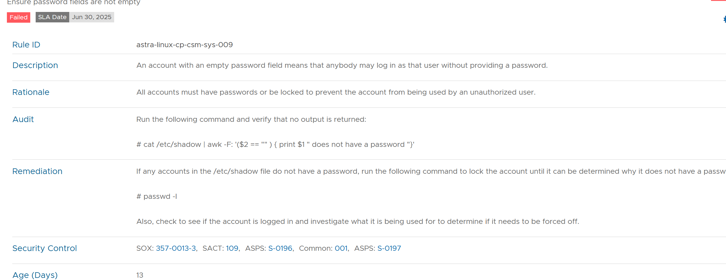
If you lock the user using passwd -l <user-name> , you have to make sure that. If this line is commented or value is no, then the account will be locked and wouldn’t be able to use SSH private/public key authentication.
- sudo vi /etc/ssh/sshd_config,
  - UsePAM yes, if this is no will not abe able to authenticate using ssh private/public key

acronyms

CSC Communication Service Customer
NWDAF 5G Network Data Analytical Function
AF Application Function
NF Network Function
CSMF Communication Service Management Function
CSP Communication Service Provider
DN Data Network
MNO Mobile Network Operator
NOP Network Operator
NSaaS Network Slice as a Service
NSaasC Network Slice as a Service Customer
NSaaSP Network Slice as a Service Provider
NSMF Network Slice Management Function
NSC Network Slice Customer
NSSMF Network Slice Subnet Management Function
NSP Network Slice Provider
SLA Service Level Agreement
SLS Service Level Specification
TN Transport Network

